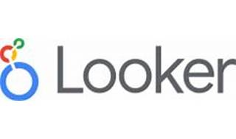



Explore

Certainly! **Looker** is a **business intelligence platform** that allows users to explore, share, and visualize data, enabling better decision-making. Here are some resources where you can learn more about Looker:

1. [**Looker Documentation**](https://cloud.google.com/looker/docs/intro): Start with the official Looker documentation to understand its features, personalization options, and how to use it effectively.
2. [**Looker Studio Help**](https://support.google.com/looker-studio/answer/6283323?hl=en): Dive into Looker Studio, a no-cost tool that lets you create customizable dashboards and reports. Learn how to turn your data into actionable insights.
3. [**Looker Tutorial on Udemy**](https://www.udemy.com/course/looker-learning-tutorial-for-beginners/): This beginner-friendly course covers Looker and LookML, guiding you step-by-step through using Looker effectively.
4. [**Looker Complete Guide on Udemy**](https://www.udemy.com/course/looker-complete-guide-to-google-looker-user-and-analyst/): Explore Looker’s features, from data analysis to building reports and dashboards. Suitable for both beginners and experts.
5. [**Looker Review and Comparison**](https://comparecamp.com/looker-review-comparison-pros-cons-pricing-one-best-business-intelligence-services/): Read pros and cons, pricing details, and insights from real users to gain a comprehensive understanding of Looker.

Remember, Looker is a powerful tool for unlocking data insights, and these resources will help you get started! 🚀🔍📊